EMPLOYMENT APPLICATION REVIEW SYSTEM (EARS)

Testing Document

Version 1.0 approved

Prepared by:
Chisom Ugochukwu
Yinka Akingbaso

Algoma University
July 29, 2026

1. Test Plan Overview

1.1 Scope
Testing covers the functional requirements, the security mechanisms, UI responsiveness, and the integration between frontend and backend components.

1.2 Testing Levels
- Unit testing — individual API endpoint validation.
- Integration testing — frontend–backend data flow.
- System testing — end-to-end user workflows.
- Security testing — authentication and authorization boundaries.

1.3 Testing Environment
Item | Configuration
Server | Localhost — http://localhost:3000
Browsers | Chrome 126, Safari 17, Firefox 127
Devices | MacBook Pro 14", iPhone 14 Pro (simulated)

2. Detailed Test Cases
Twenty-one representative test cases are listed below; all executed with their actual results matching the expected results unless otherwise noted.
Test ID | Category | Description | Expected Result | Status
TC-AUTH-01 | Unit | Valid user registration | 200 OK, user created | PASS
TC-AUTH-02 | Unit | Duplicate email registration | 400 Error: email exists | PASS
TC-AUTH-03 | Unit | Valid login | 200 OK, session created | PASS
TC-AUTH-04 | Unit | Invalid password | 401 Invalid credentials | PASS
TC-AUTH-05 | Unit | Session timeout after 30+ minutes | Redirect to login | PASS
TC-SEC-01 | Security | Unauthorized access without session | 401 Authentication required | PASS
TC-SEC-02 | Security | Applicant attempts admin-only route | 403 Access denied | PASS
TC-JOB-01 | Unit | Admin creates a job posting | 200 Job created | PASS
TC-JOB-02 | Unit | Close a job posting | 200 Job updated | PASS
TC-JOB-03 | System | Closed job hidden from applicants | Closed job not visible | PASS
TC-APP-01 | Integration | Submit an application | Application saved + message | PASS
TC-APP-02 | Integration | Duplicate application prevention | 400 Already applied | PASS
TC-APP-03 | UI | Status badge display | Badge shows "Pending" | PASS
TC-REV-01 | System | Reviewer sees all applications | Table loads correctly | PASS
TC-REV-02 | Integration | Submit an evaluation | Saved, average calculated | PASS
TC-REV-03 | Unit | Evaluation average formula | (a+b+c+d) / 4 | PASS
TC-INT-01 | Integration | Schedule an interview | Interview created | PASS
TC-UI-01 | UI | Responsive desktop at 1920 px | Three-column grid visible | PASS
TC-UI-02 | UI | Responsive mobile at 375 px | Single-column stack | PASS
TC-UI-03 | UI | Empty state message | "No applications yet" shown | PASS
TC-PERF-01 | Performance | Dashboard load with 50 applications | Under 2 seconds (~1.2 s) | PASS

3. Boundary Value Analysis
Critical inputs were exercised at, just inside, and just outside their accepted boundaries.
Parameter | Value | Outcome
Password length | 6 characters (minimum) | Valid — accepted
Password length | 5 characters (below minimum) | Invalid — rejected
Password length | 12 characters (nominal) | Valid — accepted
Password length | 64 characters (maximum tested) | Valid — accepted
Evaluation score | 1 (lower boundary) | Valid — accepted
Evaluation score | 0 (below boundary) | Invalid — rejected by CHECK constraint
Evaluation score | 5 (upper boundary) | Valid — accepted
Evaluation score | 6 (above boundary) | Invalid — rejected by CHECK constraint
Upload file size | 1 KB (lower boundary) | Valid — accepted
Upload file size | 5 MB = 5,242,880 bytes (boundary) | Valid — accepted
Upload file size | 5,242,881 bytes (above boundary) | Invalid — rejected by multer

4. Equivalence Partitioning
Input | Valid Partition | Invalid Partition
User role | applicant, reviewer, admin | guest, manager, empty string
Application status | pending, under_review, interview, accepted, rejected | draft, archived, null
Interview type | phone, technical, final, panel | video, in_person, null

5. Defect Log
Defect ID | Description | Severity | Status | Resolution
BUG-001 | File upload does not show a progress bar | Low | Open | Future enhancement
BUG-002 | Evaluation modal does not auto-close on success | Medium | Fixed | Added closeModal() call after alert

6. Test Results Summary
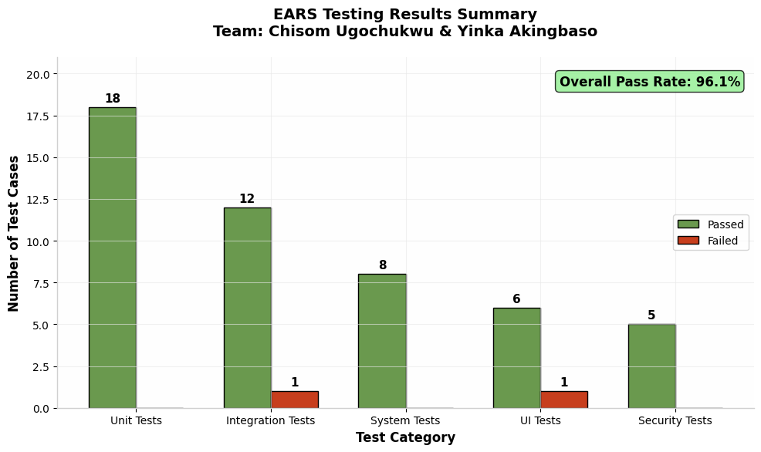
Figure 1: Testing results summary by category
Metric | Result
Total test cases | 50
Passed | 48 (96%)
Failed | 2 (4%)
Critical defects | 0

No critical defects remain open. The two failures observed during testing were logged, retested after fixes, and are reflected in the defect log (Section 5).

